HOPE GIVERS
About Us
We are humanitarian organisation that build capacities of communities to ensure empowerement of poor and excluded, elderly, women and girls and children in the field of eductaion, health and livelihood.
VISION: To create a world which is stress and prejudice free with human values, where everyone has equal opprtunity for their right to survival, protection, development and participation
MISSION: To work with the most marginalised and poor and help achieve immediate and lasting change in their lives with the support of proper education, good healthcare facilities and better livelihood opportunities.
Core Values:
1.Values and Ethics
2. Teamwork and Team based Care
3. Diversity and Inclusion
4. Honesty and Fairness

Education:

Far too often we as inhabitants of a privileged society and families take for granted the simplest of luxuries available to us. Unfortunately we easily fall victim to our routine lifestyles and fail to recognize that we have the simplest of necessities, such as clean water running from our tap while 783 million people in the world do not. It’s the same case with education and many other basic facilities unavailable to millions and if available too, its with lot of dificulties and struggle.

If we give our children the opportunity to good education; we are handing them the key to their success and the success of the nation as well. The purposes of education in a child’s life can be many- learning skills, developing curiosity and creativity, instilling discipline, developing strength and endurance, communicating, building confidence, aspiration, observation, competition and personality development to name only few. A child is the key to the success of a nation and education is the key to success of a child. It is only when a child succeeds that the nation will.

The Challenges of basic education In India:

Lack of well trained, skilled and knowledgeable teachers which provide the foundation for a high quality education system.
Teacher shortages and poorly qualified teachers are both a cause and effect of poorly paid and managed teaching cadres.
Absence of teachers during school hours is rampant. The lack of accountability and poor governance structures add to the woes.
The drop-out rates in schools, especially girls, is very high.
Dilapidated structures, single-room schools, lack of drinking water facilities, separate toilets and other educational infrastructure is a grave problem.
Many factors like poverty, patriarchal mindset, lack of toilets in schools, distance to schools and cultural elements lead to children dropping out from education.
What we Offer:
We offer training, counseling, workshop to improve the quality of education in schools to the school teachers.
Support Students with their basic requiements of school stationary, clothes, bags and other study related items.
We work on the basic infrastructure of a school,ensuring the basic facilities available to students in the form of clean drinking water, proper sanitaion and hygiene facility

Girl Child Education: In India, nearly 40% of adolescent girls in the age group of 15-18 years are not attending school. It is only through education that women can become independent and self reliant. We help these children with their education by enrolling them in proper school and take care of their expenses for their educational school kit which includes books, stationaries items, school bags, school dresses and the expense of their transport.
Sponsor 1 girl child for her whole 1 year education- 15000
Sponsor school education Kit- 8000
Health

Menstrual Hygiene: Menstrual Health and Hygiene (MHH) is essential to the well-being and empowerment of women and adolescent girls. On any given day, more than 300 million women worldwide are menstruating. In total, an estimated 500 million lack access to menstrual products and adequate facilities for menstrual hygiene management (MHM). To effectively manage their menstruation, girls and women require access to water, sanitation and hygiene (WASH) facilities, affordable and appropriate menstrual hygiene materials, information on good practices, and a supportive environment where they can manage menstruation without embarrassment or stigma.

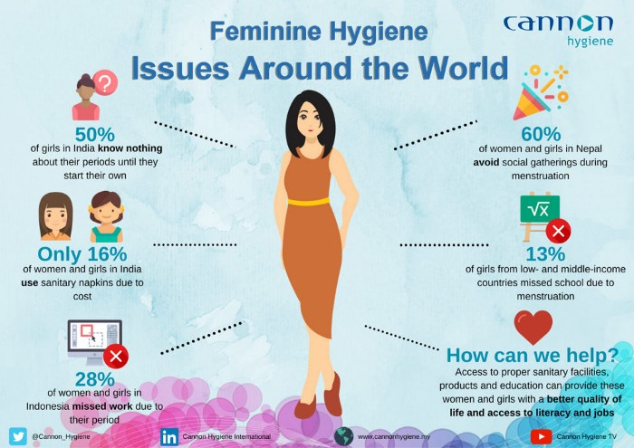
There are religious and cultural connotations the world over that associate the cycle with being “unclean”, and the visualization of menstrual blood is, for the most part, deemed radical at best, and disgusting and vulgar at worst. There are many don’ts prevailing in the society for mensturating women and they are despicable to say the least, some common don’ts are, a woman can’t bathe during mensuration, cannot visit a temple or worship, cannot touch pickles, share the same room etc and have to manage her period with make shift arrangement in the absence of sanitary pads which are rags, plastic, newspaper, wood savings, ashes only to aggravate the matter. These practices lead to many helath complications and disease.
What we offer:
We educate not only girls but their parents, , siblings, collegaues, teachers and all who needs to be informed and educated about menstural health management to break the stigma and taboo associated and prevalent in the society.
We distribute menstural hygiene kits which have (menstrual cloth, reusable pad,disposable sanitary pads, Tampon, Menstrual Cup, Soaps and sanitizers)

Prenatal and Postnatal care for expecting mothers:

Many underprivileged expecting mothers in India do not get the timely care and nutrition that helpsthem give birth to a healthy baby. It lead to the mother’s death in many cases. A woman dies every 20 minutes due to childbirth- related complications in India. Prenatal and postnatal care for expecting mothers is a must. Proper nutritional care for underpriviledged expecting mothers and babies both are of extreme importance and awarenss about the imporatnce of breastfeeding and best practices. Having a healthy pregnacy with proper prenatal and post anatl care helps aid a healthy birth.Such timely care protect the unborn child from malnourishment and helps mother stay safe and healthy themselves. The lack of it, however, can lead to complications in pregenacy and child birth both, increase the risk of miscarriages and in extreme cases, can even leas to mother’s death too.
What we offer:
Provide prenatal and postnatal care for all expecting mothers through regular tracking, monitoring and counselling
Medical support to expecting mothers during and after pregnancy and in a case of emergency
Creating awareness about the importance of breatfeeding and best practices.
Childcare: India still has one of the worst rates of child malnutrition in the world, despite decades of investment to address this problem. 2of 3 child deaths, below the age of 5, are caused by malnourishment. All children deserve a healthy childhood, but there are many in our country who do not get adequate nutrition. As a result, they mostly suffer from many diseses, stunted growth and in extreme cases, even face death. India has 5,772,472, one third of the world's malnourished children below five years -the most in the world.
What we offer
Provide support and ensure communities having access to primary helath centers and anganwadi
Helping childrens and mothers to government schemes and benefit to ensure proper nutrition
Timely immunisation for all children through the government healtcare system
Awareness drive for mothers on the importance of breastfeeding.
Livelihood
Youth Skill Development Training Programme
Skill Development is the process of identification of the skills gap in youth and providing skilling training & employment benefits to them. Skill development programs aim to acknowledge the ability of the youth and extend their support by serving them with the proper guidance, infrastructure, opportunities, and encouragement that help them achieve their ambitions. Education and skills are essential for everyone, and they both walk hand in hand in everyone's career journey.
Career Counseling : In career counselling we offer individuals proper guidance from professional counselors that provide expert advice on the potentials, Aptitude, motivations, skills and shortcomings with the use of carefully designed assessment tools. These assessment tools are both subjective and objective. After carefully studying the individual's interest and aptitude, career counselors guide individuals to set their career goals.
Job Readiness: We have millions of graduate who are unemployed currently despite of being qualified because of lack of skill in the field of communication, technology and lack of job related skills which is the most important skill set to have in order to be employed with any good company.
The skills that employers value and rely upon are changing. In turn, a “skills gap” has developed in which employers struggle to hire appropriately trained workers. People despite of having the qualification do not seem to have the right communication, aptitude, basic and nescesary computer skills, interview training. We train people and get them ready by filling these gaps with our training which help candidates crack interview with lot of confidence and land with a good employment.
What we do, We offer training in
- Communication Skills ( Spoken English verbal and written both)
- Email Drafting
- Developing Curriculum Vitae
- Interview Skills ( Mock Interview training, written questions relavent to the Job)
- Basic Computer Knowledge ( Word, Excel, PPT Etc)
- Sales Training
- Leadership Training
- Help candidates in Job Serach
- Placement with good company

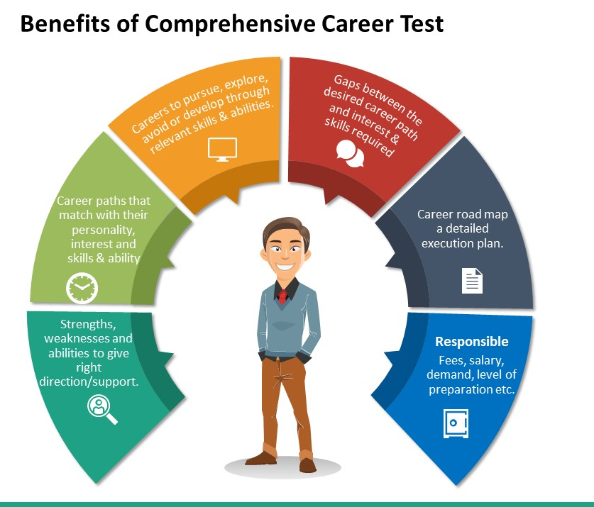

Women Empowerement:
Women account for just 10% of the world’s income and own less than 1% of the world’s property. In India, the rate of literacy for men is 80.9 per cent as compared to 64.6% for women, and their participation in labor force is only 29%. Women Empowerment implies giving them independence, and choice in how they want to lead their lives. Freedom to choose to pursue education, whom they want to marry, career, bringing up children and more. When a woman is empowered, she can identify her skills, knowledge & abilities to make her own decisions. We help women build secure and resilient livelihoods and climb out of poverty permanently mostly the one engaged in smallholder agriculture, small businesses or employed as farm or non-farm labour.
Skill development and enterprenuership: To develop the capacity, capability, and occupational & entrepreneurial skillset of marginalised women to increase their readiness for starting their own ventures.
“Women are the largest untapped reservoir of talent in the world”
-Hillary Clinton

One of the research says that around 600 million girls and women are about to join the workforce. The working culture has been transformed and it will definitely look forward to offering new opportunities to women.
We only need to properly train and equip our women workforce to benefit them in this automation change.
But somewhere we are lacking to convert this into reality because marginalized women around the globe face many obstacles to get skilled.
They are discriminated against gender inequality, lack of information and practical knowledge and poor education. That is the main reason behind the unemployability of women.

Vocational Training:
- Training in Tailoring and Embroidery:
We provide 3 month training programme on Tailoring and Embriodery. After completion of the training, each of the participants is given a free branded sewing machine and tool kit. We assist them in establishing the unit, purchase of raw material and sale of finished products. We tie up with garment factories for supply of ready made garments, social welfare department for supply of school uniforms, with wholesale cloth merchants for supply of petty coats, baby dresses. As a result they earn Rs.150-Rs.200 per day. Every women/ girl are able to earn Rs.150 to Rs.200 per day.
Sponsor Vocational Training in Tailoring and Embroidery for Women
Total Sponsorship Amount- 15000
Cost of 1 Sewing Machine- 10000
Raw materail and tool kit for 3 month training- 5000

Beautician Course: We provide training in several techniques right from eye brow making, facials, make-up, manicure, pedicure, mehendi, hair cutting, waxing along with all necessay information hat will help them run the beauty parlour businessn with proper marketing knowledge.
Nursing Course- We offer employment opportunities for aspiring nurse aides and also address the demand for health care workers by providing traing and education to girls in rural areas who have completed their basic education and are determind to work in health sector

Skill Development Training: This program is focused to enhance the employability skills of all aspirants in the age group of 15-28 years. Most of the girls trained are from informal worker families who have limited/ no access to such opportunities. The program offers them to a complete govt. certified course in computer education and Tally in a set curriculum.

Training in Hospitality: The program focused on increasing the income of young girls by enhancing their sector-specific skills such as Tourism & Hospitality and Retail followed by placement support.

Food Distribution Programme (FDP):
Under our programme FDP, an initaitive to end hunger by providing kids in slums and underprivileged societies cooked food on daily basis. It helps prevents kids from many societal mencae like begging theft, burgalry etc and lead a indepenedent and secure life. Our aim is to serve 5000 square meals on daily basis to kids in 4 states by 2023 year end.

Rehabilation and Restore Programme
In our country where the population is in excess of 1 billon, 62.5 million people use alcohol, 8.75 million use cannabis, two million use opiates, and 0.6 million use sedatives or hypnotics. Over 10 crore drug users of all kind we have in our country.The no.is increasing significantly every year, resulting in families break up, relationship, being the reason for many crimes and atrocities.The most disturbing aspect of these addictions are children being involved from a very early age in such activities, we have millions of children who have taken to drugs in the absence of purpose and hope.
Among many raesons for a child to runaway from their homes, the most prominent are ill treatment of a child at home, to find work in cities, drug addiction etc. Girls are as likely as boys to run away from homes due to parental neglect or dysfunctional families.
We help these children under our restoration and rehabilition progrmme, provide them shelter a safe place to stay and recover, help them with medical services which includes help with substance abuse and addictions. Children are engaged in non formal education with proper counselling, yoga and meditaion alongwith food and clean drinking water facilities.
To support a child for a month treatment under our rehabilation and restore programme, which includes tracing and identification, counseling, medical treatment, medicine, food and shelter- 5000.

Old age
Currently there are 138 million elderly livin in India. As childhood days, this age also requires care, protection and support. Aging comes with many challenges. Growing older means no jobs, hence less incomes. Issues ranging from health to finance to many social discrimination at the family level to societal level are the few issues elederly people have to grapple with on their day to day life, being considerd as a liablity, many are forced to live their life in the oldage home when they require the support and care of their families the most. Mistreatment and abuse of the elderly is a major social problem.
With the biology of aging, the elderly sometimes become physically frail. This frailty renders them dependent on others for care—sometimes for small needs like household tasks, and sometimes for assistance with basic functions like eating and toileting. Unlike a child, who also is dependent on another for care, an elder is an adult with a lifetime of experience, knowledge, and opinions—a more fully developed person. This makes the care-providing situation more complex.
What we Do: We at Hopegivers through our local partner organisation support these elederly people for their requirement of proper shelter through our old age homes and provide all basic amenities for their well being like proper food, medicines, clothes. We also conduct free yoga and mediation sessions at all our oldage homes for the elderly people for their healthy mind and body. This really help them in keeping their spirit up and vibrant after having gone through all the trauma and trubulent in their life. “ A strong body cannot maintain a weak mind but a strong mind can always maintain a weak body. Menatl aspect is the key and to come out of the mental trauma, yoga and mediation plays a vry important and significant role in their life.

Education | - To support 1 girl child for her whole 1 year education-  15000 | 2. To support school education Kit for a girl child for whole 1 year (Books, Stationary items, school Bags, School dress, Water bottle etc) -  8000 | 3. To promote socio-emotional well being apart from education in a school, supporting a school with games equipments, like, carom, football, chess, cricket bat and ball, badminton, voleyball, skipping ropes etc-  6000 | 4. To adopt and support a public school and scale up its basic infrastucture (water, saniation and hygiene facilities for students other infrastructure facilities like chairs, tables and other equipments)-  50000
Health | 1.To provide menstural hygiene kit to a girl child (Sanitary pads,soaps, towels, napkins, tissue paper,handwash gel, vaginal wash etc)  4000 | 2.To Provide prenatal and postnatal care to a expecting mother through regular tracking, monitoring and counselling –  10000 | 3.To provide basic helath care facilities and medical treatment alongwith the medicinal support to an extremely poor family (financially weak) at the time of their requirement and need-  15000 | 4. To sponsor a free basic routine health check up camp for a community (minimum of 100 People for test like blood sugar, BP, liver, Kidney,anaemia etc-  20000
Livelihood | 1. To Support Vocational Training in Tailoring and Embroidery for Women  Total Sponsorship Amount-  15000 | 2.To support one women for a sewing machine-  10000 | 3. To support a youth for its skill development training which includes (computer literacy, spoken english, Job interview training, career counselling and job readiness training) for a period of 3 month-  10000 | 4. Vocational traing for a differently abled for candle making, paper bags making,stitching etc for a period of 3 month-  10000
Rehabilation & Restore | 1.To support a child for a month treatment under our rehabilation and restore programme, which includes tracing and identification, counseling, medical treatment, medicine, food and shelter-  5000 | 2.To conduct a workshop for school children on drug abuse and addiction-  5000 | 3.To organise a yoga and meditation camp for these addicts to calm the erratic mind and build up resistance for a period of 3 months-  10000 | 4.To support a larger group of peopleof 10 & more, grown ups and adults with our bio,pshyco and socio model of recovery which includes counselling, therapy, medical treatment –  25000
FDP (Food distribution Programme) | 1.To support a family of a rag pickers, saniation workers for a month with a grocery kit( 20 kg rice, 5 Litres Cooking Oil, 5Kg lentils, vegetables etc) –  5000 | 2.To support 100 school children for their mid day meals in school with home cooked food-  10000 | 3.To support 100 children living in slums or an orphanage for one day home cooked food-  10000 | 4.To support 100 people living on the road side, under flyovers, beggars and homeless for home cooked food for a day-  10000
Oldage | - To support an elderly for a wheel chair  10000 | 2. To support an elderly for a walker, clothes and adult diapers -  10000 | 3. To support an elderly for one month ration alongwith financial help -  15000 | 4. To support an elderly for his/her physiotherapy treatment for a month along with medicinal support-  15000

Volunteer & Internship
“Nothing is bigger & stronger than a heart of a Volunteer”.
An act of kindness, something which springs on its own,feeling the need to do something, especially for others willingly, without being forced or paid to do it, just to bring change and smile in others life, being avialable for others is what volunteerism is all about. Giving back to the communities.
We encourage and invite individuals for volunteer opportunities-to work for the welfare of the society.
You may write to us at contactus@hopegivers.in, if you wish to do any volunteer work or internship for the cause.

